TITLE : Soil classification & crop suggestion using machine learning

# Abstract

Crop prediction is an essential predictive analytics technique in the agriculture industry. It is an agricultural practice that can help farmers and farming businesses predict crop in a particular season when to plant a crop, and when to harvest for better crop yield.

# Introduction:

There are so many soil series available in India. Every soil series have different features and every soil is suitable for different crop. Sometimes or we can say every time it happens that farmer soil is best for some specific crop but as he don’t know. The main purpose of the proposed work is to create a suitable model for classifying various kinds of soil series data along with suitable crops suggestion.

Series are recognized by machine learning methods using various chemical features and possible crops for that soil series are suggested using geographical attributes. Soil is one of the key components in agricultural field for yielding crops. Soil classification philosophies follow the existence knowledge and practical circumstances. On the land surfaces of earth, classification of soil creates a link between soil samples and various kinds of natural entity

# Literature Survey:

|  |  |  |  |
| --- | --- | --- | --- |
| Sr no. | Paper name | Author name | Description |
| 1 | A study on various data mining techniques for crop yield prediction | Yogesh Gandge; Sandhya | Predicting a crop well in advance requires a systematic study of huge data coming from various variables like soil quality,pH, EC, N, P, K etc. As Prediction of crop deals with large set of database thus making this prediction system a perfect candidate for application of data mining. Through data mining we extract the knowledge from the huge size of data. This paper presents the study about the various data mining techniques used for predicting the crop. |
| 2 | Crop prediction using predictive analytics | P. S. Vijayabaskar; R. Sreemathi; E. Keertanaa | This work is to construct a model for testing the soil fertility. It also suggests the crop which has to be planted depending upon the value obtained from the sensor. It also provides the regional wise information about the crop in the form of graph. |
| 3 | Crop Yield Prediction using Machine Learning Techniques | Ramesh Medar; Vijay S. Rajpurohit; Shweta Shweta | The concept of this paper is to implement the crop selection method so that this method helps in solving many agriculture and farmers problems. This improves our Indian economy by maximizing the yield rate of crop production |
| 4 | An Analytical Approach for Soil and Land Classification System using Image Processing (2020) | Prof. A. V. Deorankar.  Ashwini A. Rohankar. | The emphasis is focused on the analytical study of various advanced and efficient classification mechanisms and techniques. |
| 5 | Supervised Machine learning Approach for Crop Yield Prediction in Agriculture Sector (2020) | Dr. Y. Jeevan Nagendra Kumar, V. Spandana, V.S. Vaishnavi, K. Neha | Crop yield prediction incorporates forecasting the yield of the crop from past historical data which includes factors such as temperature, humidity, ph, rainfall, crop name. |

# Existing System:

* In existing system, traditionally without knowing the type of soil, without knowing suitable crop.
* Farmer plants his farm and it many times gives him loss. Farmer don’t have the knowledge of crop and soil also.
* Crop yield prediction incorporates forecasting the yield of the crop from past historical data.

**Methodology:** Machine Learning

**Design:** Tiknder

**Algorithms**: CNN (CONVOLUTIONAL NEURAL NETWORKS)

**Proposed System:**

* We need to know the features and characteristics of various soil types to understand which crops grow better in certain soil types.
* Machine learning techniques can be helpful in this case.
* Then apply apriority Mining process to generate an association rule for finding suitable crops for the specific soil.
* Soil series and land type combine represents the soil class in the database.
* The machine learning methods are used to find the soil class (i.e. soil series and land type). Algorithm are used: CNN.

**ARCHITECTURE**

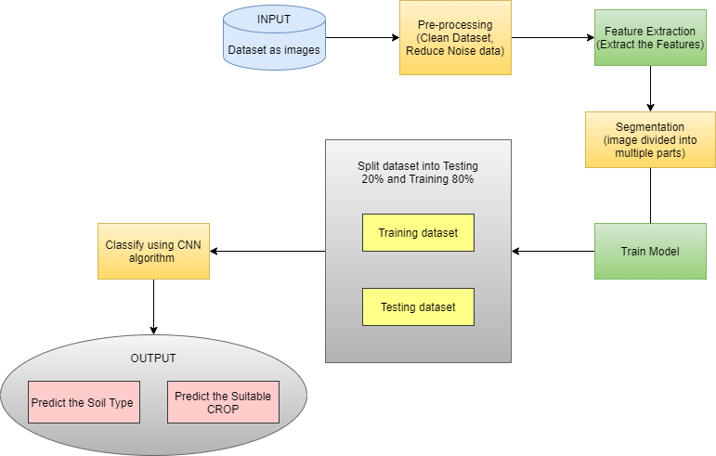

# Project Plan:

|  |  |  |  |  |
| --- | --- | --- | --- | --- |
| **NO** | **TASK** | **DURATION**  **(Days/Months)** | **START**  **DATE** | **END DATE** |
| **1** | Group Formation |  |  |  |
| **2** | Decide Area Of Interest |  |  |  |
| **3** | Search Topic |  |  |  |
| **4** | Topic Selection |  |  |  |
| **5** | Sanction Topic |  |  |  |
| **6** | Search Related  Information |  |  |  |
| **7** | Understanding  Concept |  |  |  |
| **8** | Search Essential Document  (IEEE & White Paper,  Software) |  |  |  |
| **9** | Problem Definition |  |  |  |
| **10** | Literature Survey |  |  |  |
| **11** | SRS |  |  |  |
| **12** | Project Planning |  |  |  |
| **13** | Modeling& design |  |  |  |
| **14** | Technical Specification |  |  |  |
| **15** | PPT |  |  |  |

**SRS:**

# INTRODUCTION

## Purpose

Crop prediction is one of the challenging tasks in agriculture. It plays an essential role in decision making at global, regional, and field levels. The prediction of crop yield is based on soil, meteorological, environmental, and crop parameters.

## Document Conventions

UML: Unified Modelling Language DB: Database

TK: Tkinder

ML: Machine Learning CM: Camera Module

HCI: Human Computer Interface

## Intended Audience and Reading Suggestions

This is grateful human interaction with machine learning according to this interaction we can easily find out what we want. we machine earing language (python) easy to find out solution. Our main motive is give output accuracy. This project GUI Design in Tkinder and the soil images dataset use for classify the data.

## Project Scope

* To know the actual situation of crop production.
* Improve Accuracy
* User Friendly And Easy To Understand
* To Detect Crop

# Overall Description

## Productive Perspective

Different soil classifications for

It has different soils like red soil, black soil, sandy soil etc.,

1. Image Processing Module

* Image Processing module is used to Preprocess dataset, data mining, transforming raw data into understandable format, remove the noise and blurr part of the dataset.
* **Classification :-** Classify the soils through CNN algorithm.

1. Tkinter GUI Based software

Tkinter is a graphical user interface (GUI) module for Python, you can make desktop apps with Python. You can make windows, buttons, show text and images amongst other things.

## Product Features

With help of image dataset we can perform different image operations easily. With less distance and easy User interface we can detect soil type and predict suitable crops and see output on window.

## Operating Environment

Real time anaconda operates using:

* + - Algorithm: CNN
    - Trained dataset of soil types : .jpeg format (as it is in image format)
    - Platform: Python
    - User dependent and Single user system

## Design and Implementation Constraints

Python ,DBSQlite Database Connectivity.

## Assumptions and Dependencies

For e.g. if user is give input as food images:

Firstly, user give input as food image then pre-processing on given input removing unwanted data, and feature Extraction and then classify the image using CNN. And give output.

# System Features

* 1. **Functional Requirement:**

Performance Requirement

Performance of the functions and every module must be well.

The overall performance of the software will enable the users to work efficiently.

Safety Requirement

The application is designed in modules where errors can be detected and fixed easily.

This makes it easier to install and update new functionality if required.

Security Requirement

User’s all details are confidentiality. Data is modified by authorized person in authorized manner. User need to go throw authentication process. Permissions to be assigned to All Authenticated entities

# External Interface Requirements

## User Interfaces

* + - Front End Software: Tkinder
    - Back End Software: Python

## Hardware Interfaces

* + - As it is Python based application so it can run on any platform with minimum hardware RAM as well as Storage use

## Software Interfaces

|  |  |
| --- | --- |
| Software Used | Description |
| Operating System | As developed application should be open source so we have chosen Python so it can run on any platform rather  on any Operating system |
| Edge Detection  Algorithm | This algorithm is used to detect soil types so that user can see result of their crops prediction based on soil types. |

* 1. **Communication Interfaces**

This project is based on Crop Prediction with machine learning approach.

Communication interfaces used through simple input image and Image processing which takes input and show output on screen.

# Non-functional Requirements

## Performance Requirement-

* The performance of the functions and every module must be well.
* The overall performance of the software will enable the users to work efficiently.
* Performance of tracking of data should be fast.
* Performance of the providing virtual environment should be fast.

## Safety Requirement-

The application is designed in modules where errors can be detected and fixed easily. This makes it easier to install and update new functionality if required.

## Software Quality Attributes-

Our software has many quality attribute that are given below:-

* Adaptability: This software is adaptable by all users.
* Availability: This software is freely available to all users. The availability of the software is easy for everyone.
* Maintainability: After the deployment of the project if any error occurs then it can be easily maintained by the software developer.
* Reliability: The performance of the software is better which will increase the reliability of the Software.
* User Friendliness: Since, the software is a GUI application; the output generated is much user friendly in its behavior.

# Algorithms: CNN

* **CONVOLUTIONAL NEURAL NETWORKS** : A Convolutional Neural Network (CNN) is a Deep Learning algorithm which can take in an input image, assign importance (learnable weights and biases) to various aspects/objects in the image and be able to differentiate one from the other.

1. Input image (starting point)
2. Convolutional layer (convolution operation)
3. Pooling layer (pooling)

Input layer for the artificial neural network (flattening)

* Convolutional Neural Networks specialized for applications in image & video recognition. CNN is mainly used in image analysis tasks like Image recognition, Object detection & Segmentation.
* There are Four types of layers in Convolutional Neural Networks:
* 1) Convolutional Layer : In a typical neural network each input neuron is connected to the next hidden layer. In CNN, only a small region of the input layer neurons connect to the neuron hidden layer.
* 2) Pooling Layer : The pooling layer is used to reduce the dimensionality of the feature map. There will be multiple activation & pooling layers inside the hidden layer of the CNN.
* 3) Flatten : Flattening is converting the data into a 1-dimensional array for inputting it to the next layer. We flatten the output of the convolutional layers to create a single long feature vector.
* 4) Fully-Connected layer : Fully Connected Layers form the last few layers in the network. The input to the fully connected layer is the output from the final Pooling or Convolutional Layer, which is flattened and then fed into the fully connected layer.

# CONFERENCE/JOURNAL PAPERS SUPPORTING PROJECT IDEA:

* [1] Prof. D.S. Zingade ,Omkar Buchade ,Nilesh Mehta ,Shubham Ghodekar ,Chandan Mehta “Crop Prediction System using Machine
* Learning”.
* [2] Ashwani kumar Kushwaha, Swetabhattachrya “crop yield prediction using agro algorithm in hatoop”.
* [3] Girish L, Gangadhar S, Bharath T R, Balaji K S, Abhishek K T “Crop Yield and Rainfall Prediction in Tumakuru District using Machine Learning”.
* [4] Rahul Katarya, Ashutosh Raturi, Abhinav Mehndiratta, Abhinav Thapper “Impact of Machine Learning Techniques in Precision Agriculture”.
* [5] Pijush Samui, Venkata Ravibabu Mandla, Arun Krishna and Tarun Teja “Prediction of Rainfall Using Support Vector Machine and Relevance Vector Machine”.
* [6] Himani Sharma, Sunil Kumar “A Survey on Decision Tree Algorithms of Classification in Data Mining”.
* [7] Pavan Patil, Virendra Panpatil, Prof. Shrikant Kokate “Crop Prediction System using Machine Learning Algorithms